TEAM 2 Pitch Document

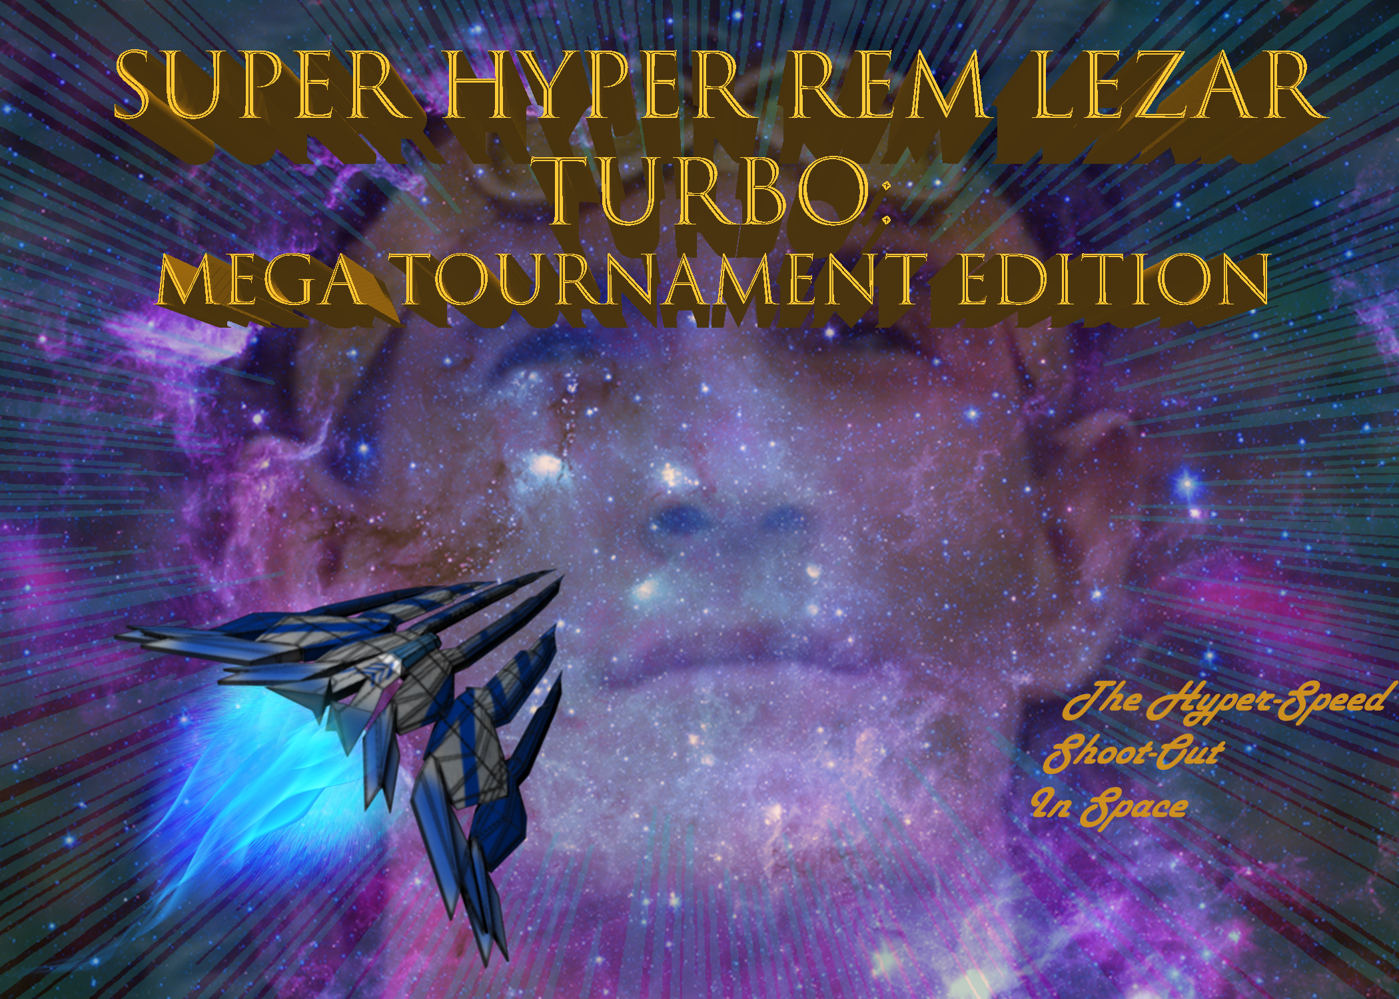

**Game Overview:**

The game takes place in space, with the player controlling a spaceship. Your enemies are bug type enemy spaceships. You work your way through the levels until you fight the boss.

**Gameplay:**

-The Gameplay is a top down space shooter similar to Raiden. Where you fly through space destroying asteroids, grunt enemies and bosses alike.

**Features:**

-Space Flight

-Different power ups

-Intense Boss battles

**Game Genre:**

-2.5 D Space Shooter

**Art Genre:**

-Realistic

**Mechanics:**

-Shooting Lasers

-Spinning dodge/deflection (has cool down)

-Homing Missile

-Power ups (Boosted Attack)

**Enemy Types:**

-Scarab: The Scarab type ship will attempt to fly into you and if they succeed in doing so they will detonate on contact.

-Killer Bee: The Killer Bee type ship fly will fly in wave like pattern across the screen and shoot burst from their guns when they face the middle of the screens

-Wasp: The Wasp type ship stays at the top of the screen firing a beam that goes across the screen and then the ship strafes slightly to the left or right for a few seconds then stops and flies straight down.

Boss: The Boss type enemies have more health and drastically different attacks

**Progression:**

-You progress through the levels by defeating the enemies until you reach the boss of the level. Once the boss is defeated you progress on to the next level. You collect power ups throughout the game to make your ships and weapons stronger. Once you go through all of the levels and defeat the final boss the game ends.

**Level:**

- As you progress through each level the game gets progressively harder, until you reach the end and beat the game

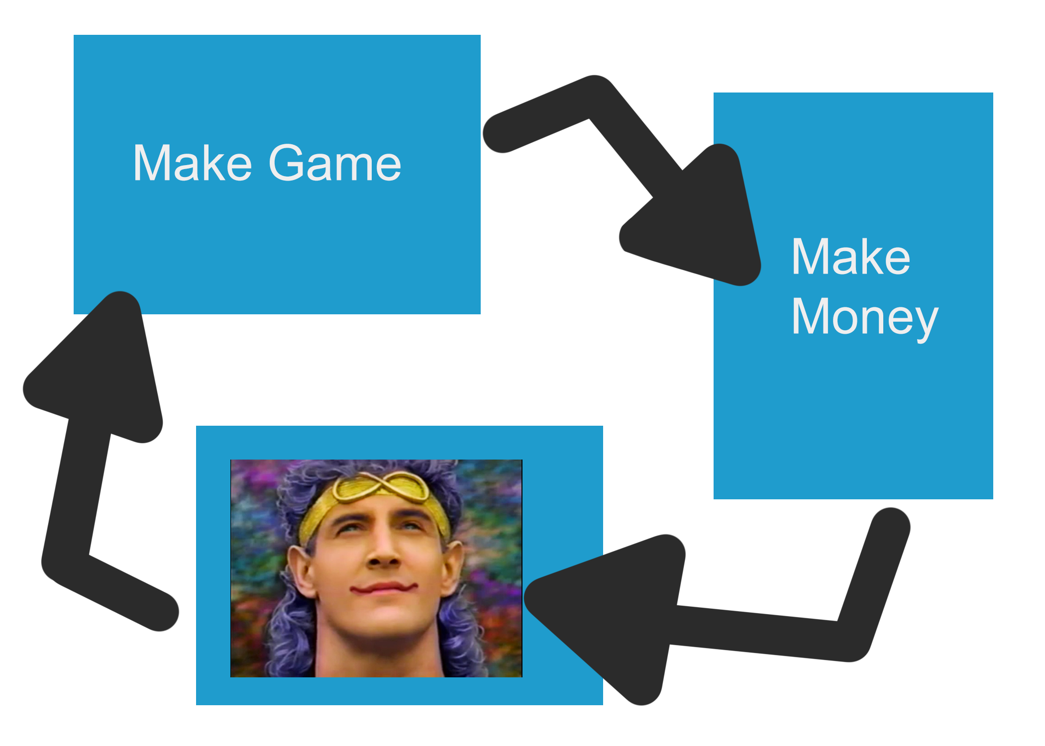

**Drive:**

-The drive for the game is to get stronger and beat the more challenging levels until you finally reach the end of the game

**Platform:**

-PC

**Target Audience:**

-Science Fiction Fans

- Vertical shooter / Bullet Hell Fans

**Team Members / Jobs:**

Ryan: Ship Models/Textures/Programming(Misc.)

Barry: Environment Models/Textures/Audio /Programming(Misc.)

Chives: Programming (Main)

Devin: GDD/Programming(Misc.)

**Timeline to beta**

3 to 4 weeks until our game can reach beta

**Similar Games**

Games similar to our game are Raiden, Gemini Wings, and Xevious.

**Monetization**

This game is a one time purchase with no extra ways of monetization currently planned.

